JSS PUBLIC SCHOOL
JSSTIS CAMPUS MYSURU

AISSE (CBSE) CLASS X RESULTS 2021-22
SCHOOL TOPPERS FOR THE ACADEMIC YEAR 2021-22
It gives us immense pleasure to announce with pride that our school has secured 98.7 percentile with 5 centum, with 15 students scoring 90% and above with 36 distinctions, 28 First class, and 5 Second class.
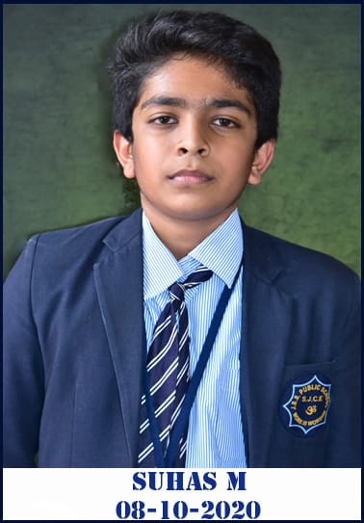
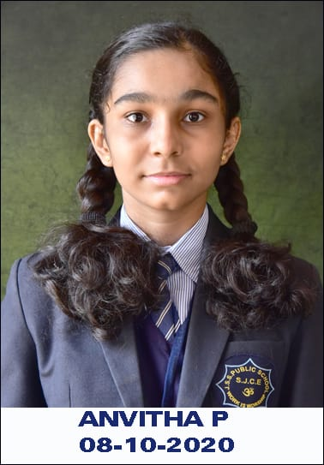
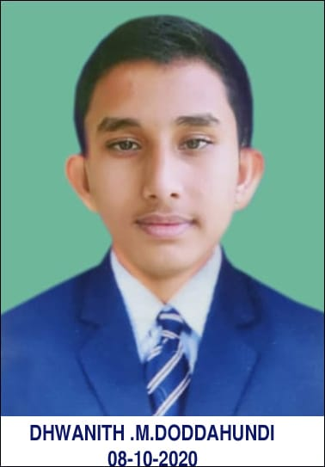
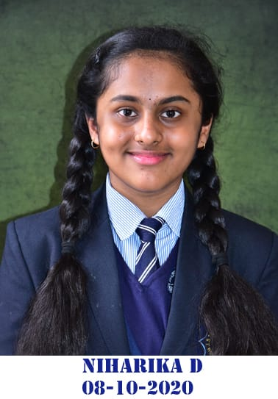
The management and the staff congratulate the students for their commendable feat.

SUHAS M NIHARIKA D DHWANITH M D ANVITHA P
97.8% 97.2% 96% 95.4%
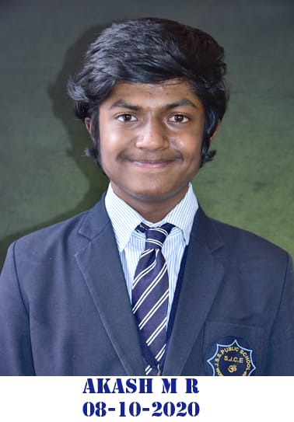
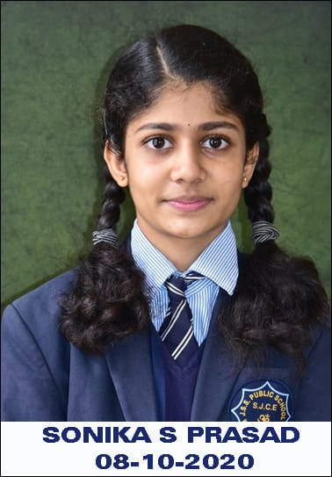
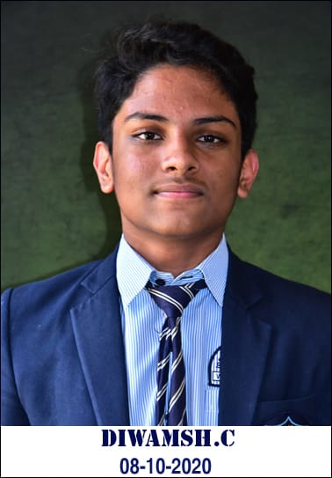
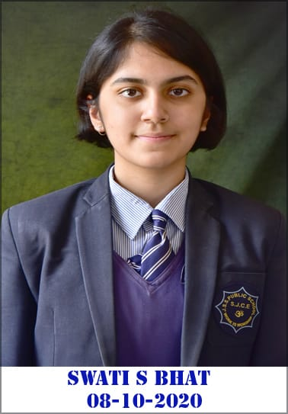

AKASH M R SWATHI S BHAT DIVAMSH C SONIKA S PRASAD
95% 94% 93.4% 93.4%
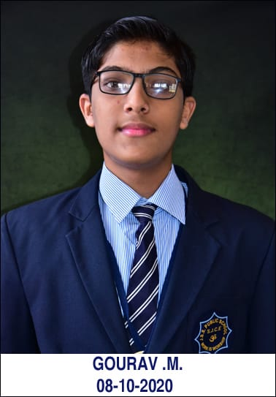
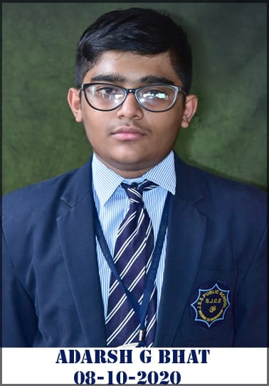
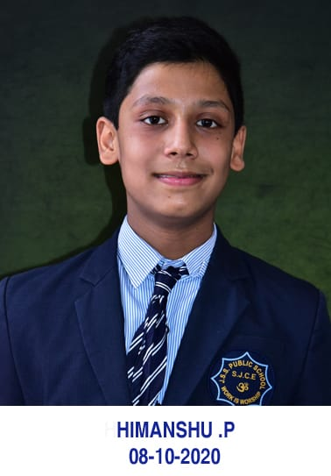

PRABHANJAN T R HIMANSHU P ADARSH G BHAT GOURAV M
92.6% 92.2% 91.6% 91.4%
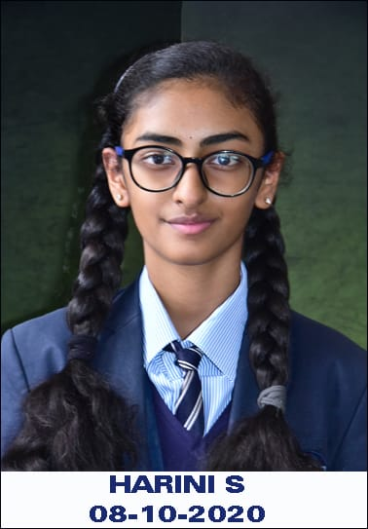
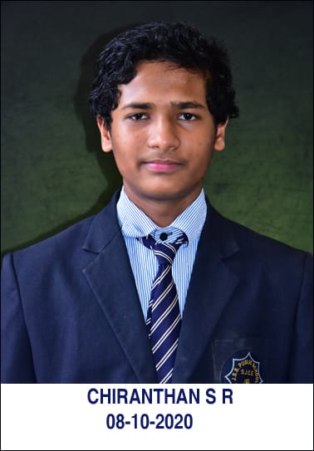
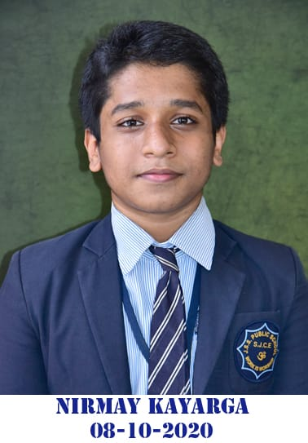

NIRMAY KAYARGA CHIRANTHAN S R HARINI S
91% 90.6% 90.6%

